**6th June – Q News**

Dear

This week’s email is short and sweet!

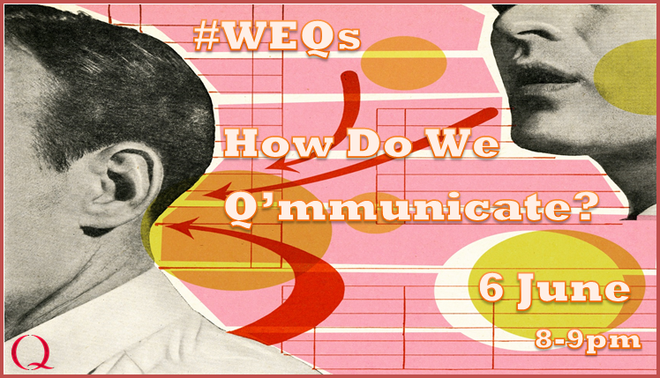**Twitter Hour tonight at 8pm-9pm #WEQs**



**Check out our new Q page!**

Thanks to our fantastic Q, Vardeep, we have begun the process of updating our Q website to provide you with a place to upload your **case studies**. The site is yet to be completed but we’re working on it…

**In the meantime, have a perusal and send me your thoughts….**

<http://www.weahsn.net/what-we-do/west-of-england-academy/academy-programmes/the-q-initiative/>

**Q Interests**

|  |  |  |
| --- | --- | --- |
| **N**atasha  **Owen**    [**Natasha.Owen@wvt.nhs.uk**](mailto:Natasha.Owen@wvt.nhs.uk) | |  |
| **Role**  Clinical Quality Improvement and CQUINS Manager | **Organisation**  Wye Valley NHS Trust |  |
|  |  |  |

For me, Q is a learning environment. A place to get new ideas, understand different methods and approaches to the application of improvement science in a health organisation. How we achieve improvement is something we don’t talk about often in our reports, project write ups, presentations or posters and yet it is so valuable to spreading improvements.

**The Health Foundations –** [**Election Briefing paper 3**](http://www.health.org.uk/publication/election-briefing-sustainable-workforce)



In this third briefing, we consider what steps might be needed to make sure the NHS and social care in England have enough of the right people to deliver high quality care in the future

**Important Dates**

**6 June –** Twitter Hour round 2

**16 June –** Achieving Better Care: Sharing Quality Improvement Strategies – QI Conference in Taunton

**30 June –** Improvement Coach Refresher (for those of you who have trained to be an Improvement Coach and would like a refresher course) **POSTPONED**

**4 and 5 July –** Improvement Coach Programme (for those of you who have not yet trained to be an Improvement Coach) - **FULL**

**13 July –** The Habits of an Improver with Bill Lucas [**Register here**](https://www.eventbrite.co.uk/e/habits-of-an-improver-with-bill-lucas-tickets-34231087103)

**6 September –** SAVE THE DATE! Jem Wall will be hosting our second masterclass. Stay tuned for further details.

**7 September –** SAVE THE DATE! Jem Wall will be hosting our second masterclass. Stay tuned for further details.

**Ciao for now, folks!**

**Sophie Bland**

**Academy Coordinator**

***West of England Academic Health Science Network  (WEAHSN)***

South Plaza, Marlborough Street, Bristol BS1 3NX

**Tel:** 0117 900 2443 (Ext: 2443) **Email:** [sophie.bland@weahsn.net](mailto:sophie.bland@weahsn.net) **Website:** [www.weahsn.net](http://www.weahsn.net/) **Twitter:** @QIWEAHSN **LinkedIn:** [West of England Academy](uk.linkedin.com/in/westofenglandacademy)