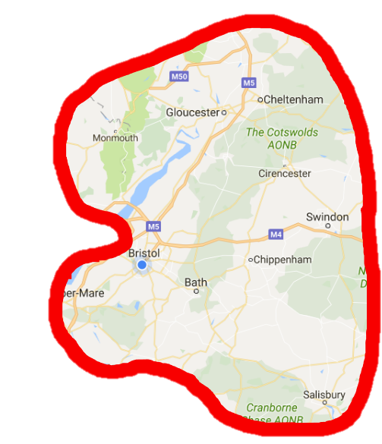Good afternoon cid:image008.png@01D2C8CE.84FF55B0 !

Here we are again - our second Q News email, and there’s plenty in here to feast your eyes upon!

Firstly, the **Q Contacts Booklet** - thank you to all of you who emailed me with an updated email address or phone number. I have updated the booklet and have added portraits taken at the Welcome to Q event. Speaking of which, did you know that our photographer, George Chan, works on David Attenborough productions? This explains the fantastic quality of our portraits! So do have a good flick through the booklet and admire. Not everyone has a photo yet, so please do send one my way if you didn’t attend the Welcome event. As we are part of the Q-mmunity, we’d really like it if we could all get together to get to know one another. This Q Contacts Booklet is a useful tool for this – email each other, call each other, throw a tea party…whatever takes your fancy.

To make networking a bit easier, I have attached a list of Qs in our 3 STP footprints:

* Bristol, North Somerset, South Gloucester
* Bath and North East Somerset, Swindon and Wiltshire
* Gloucestershire

In this Excel sheet you can filter your searches, for example, if you were to search for all the Qs in Bristol, click on the little arrow next to the header ‘Organisation Name’ and select only the Qs who are in Bristol.

As you Qs are an interesting bunch we’d like to gather your interests so that we can help you connect with the Qs that you have interests in common with. These will go on the Excel sheet and shared with everyone in the next Q News email – so, let me know where your improvement interests lie, be it Cardiology, Patient Safety or technology, and I shall do the rest!

Secondly, we’d like you to **share your projects** via the wonder of this bi-weekly email.

Have you made a short film about the project you’re working on? Do you know of projects that have videos and you’d like to share them?

Alternatively, if you have a fancy phone with video capabilities, film a 5 minute (max) explanation of what you’re working on or have worked on.

Or if you’re camera shy, we’d love to share your written case studies instead. Email these to me before 22nd May. Find the Q Cast template attached for guidance.



On to number three –In the spirit of acronyms in the NHS - **QIQ&A**! I like this one because it gives us all the opportunity to ask anything technical about Quality Improvement. Don’t be shy – email me anything you may want to know and I will share it anonymously with the rest of the Qs who will then email me their answers. These will follow in the next Q News emails. I’ll go first…

**Question to Qs…**

Those of you who attended the Welcome To Q event may remember that you had a postcard which prompted you to think of an improvement idea and which Q you should connect with in order to get the improvement ball rolling. **Did you try your idea out? Did you connect with the Q?**

And last but not least, **Twitterversity!**

A lot of you have signed up to our upcoming events (see below) hoorah! These will be fantastic, so don’t delay in siging up if you haven’t yet.

Our knowledgable and wise West of England AHSN Q, Nathalie Delaney, will be hosting a How To Use Twitter session at the beginning of the Habits of an Improver workshop on the 13 July. In order to help get the session underway we strongly advise you to sign up to Twitter before the workshop. Being on Twitter is most certainly not a prerequisite to being a Q, however, we are about to host our Twitter Hours once a month and it would be great to have your voices heard during these hours. If you’re not sure how to sign up, [click here](http://www.wecommunities.org/resources/twitterversity1) and follow steps 1-3.

Speaking of which, please [click here](https://storify.com/WEAHSN/q-mmunity-twitter-hour-weqs) to see how our very first Twitter Hour went. There are a few tweaks to be done before our next session but we feel that it was a fantastic start to opening up discussions amongst the Q-mmunity. In fact, the conversation was shared right across the country. It’s also a fantastic way of involving colleagues who may have missed the opportunity to apply last year, to join in the conversation.

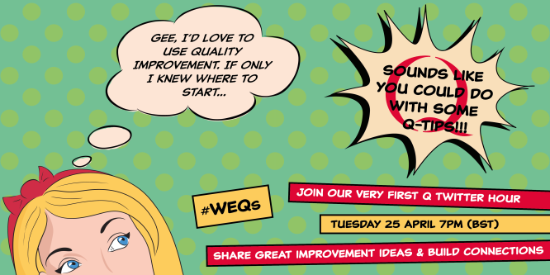

**Important Dates:**

**23 May –** Twitter Hour round 2. More on this to come….

**16 June –** Achieving Better Care: Sharing Quality Improvement Strategies – QI Conference in Taunton. [Register here](https://www.eventbrite.co.uk/e/achieving-better-care-sharing-quality-improvement-strategies-tickets-33150933334)

**30 June** – Improvement Coach Refresher (for those of you who have trained to be an Improvement Coach and would like a refresher course) [Register here](https://www.eventbrite.co.uk/e/refresher-for-improvement-coaches-tickets-34237695870)

**4 and 5July** – Improvement Coach Programme (for those of you who have not yet trained to be an Improvement Coach). [Register here](https://www.eventbrite.co.uk/e/improvement-coach-programme-tickets-34272169983)

**13 July** – The Habits of an Improver with Bill Lucas. [Register here](https://www.eventbrite.co.uk/e/habits-of-an-improver-with-bill-lucas-tickets-34231087103)

**In the words of Porky Pig, that’s all folks…**