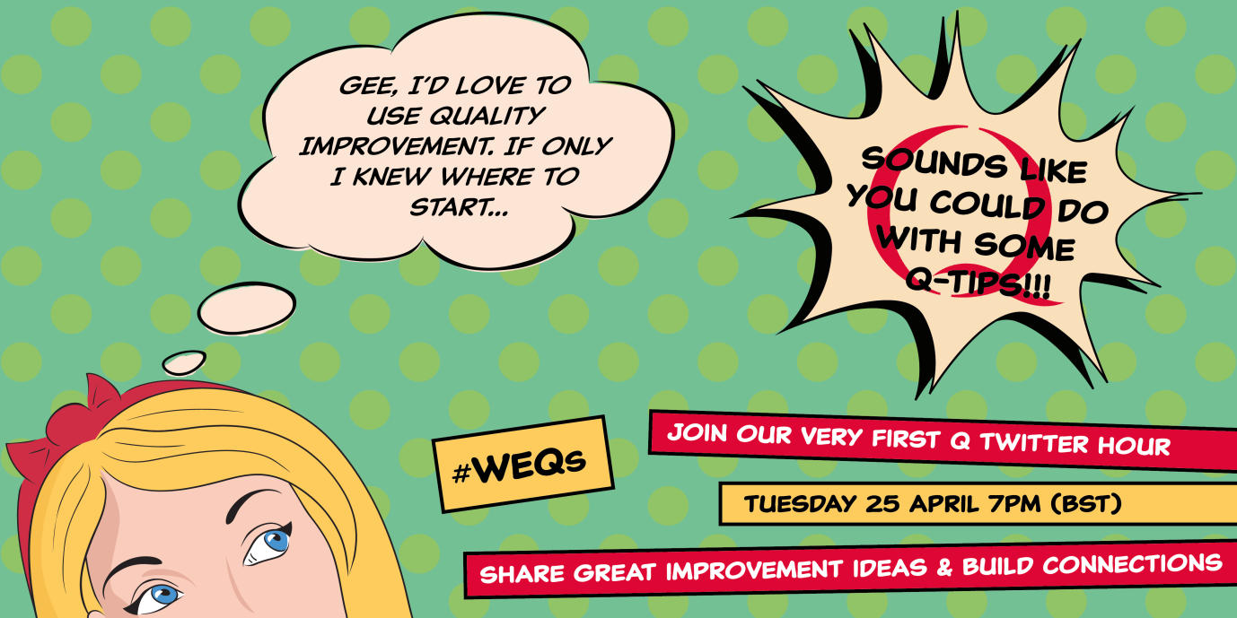

Good afternoon cid:image007.png@01D2BDC9.4BC67860

As you have now, well and truly, been inducted in to the Q-mmunity, we would like to offer you the chance to network and share your Q-Tips by the power of Twitter. Being a Q is all about **sharing best practice, ideas, methodology and experience** so we have come up with the rather inspired hashtag #WEQs (West of England Qs).

In response to feedback collected at our Welcome to Q conference we have therefore decided to host our very first Twitter Hour to get conversation flowing amongst the Q-mmunity. You can join as an active Tweeter, or if you’re more comfortable reading the conversation whilst watching TV or cooking your tea, please feel free. Perhaps you’ll be inspired to re-Tweet a tip or two…

Join us at 7pm **tonight** and share your Q-Tips with us and your fellow Qs!

Secondly on the agenda, we have created a Qs Contacts booklet. This is attached as a PDF but if you’d like it printed, please ask. I’m more than happy to send you a copy in the post.

The emails and numbers of your fellow Qs are as up-to-date as possible, but if anyone wishes their details to be altered in any way then it can easily be changed. Please bear in mind that this is a working document so it can be changed and shared again at any time! The PDF is in booklet layout which is why the alphabet seems to be dis-ordered, once printed it should be in the correct order. If you would like any corrections, please let me know.

Example below:

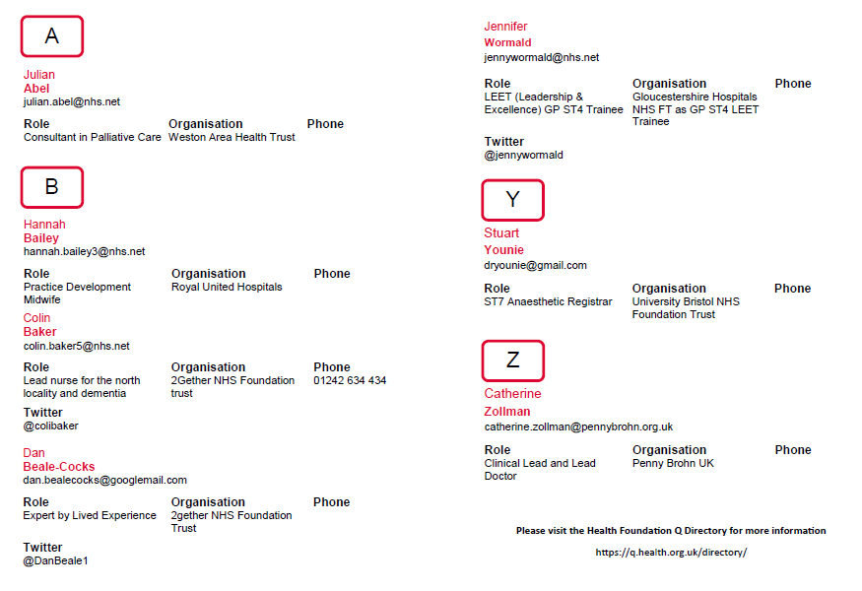

Remember, the Health Foundation’s Q Directory is online at <https://q.health.org.uk/directory/> where you can put names to faces as well as contact each other. If you’d like your photo adding to the Q Contacts Booklet, please let us know!

That’s all for now, folks. Don’t forget - you can always email or call me directly if you need any help or have something inspiring you’d like to share.

**Over and out.**