Good morning Qs,

I hope you’re well on this fine, rainy day…

In the run up to the election on the 8th June The Health Foundation are writing 3 briefings about the future of the NHS. The first two have been published online so we thought we would share these with you.

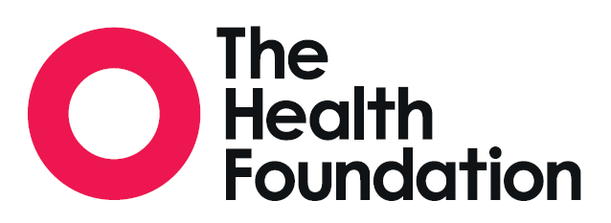

1. Election Briefing: NHS and social care funding – 3 unavoidable challenges

<http://www.health.org.uk/sites/health/files/Election%20briefing%20NHS%20and%20social%20care%20funding.pdf>

1. Election Briefing: Quality of care in the English NHS – in the balance

<http://reader.health.org.uk/InTheBalance>

You can expect to see briefing number 3 very soon…



***On a lighter note, don’t forget that spaces are running low for our events****!*

* For those of you who trained to be **Improvement Coaches** last year and would like a **refresher**, [sign up here](https://www.eventbrite.co.uk/e/refresher-for-improvement-coaches-tickets-34237695870)
* For those of you who are yet to train to become an **Improvement Coach**, [sign up here](https://www.eventbrite.co.uk/e/improvement-coach-programme-tickets-34272169983)
* For ALL of you who want to attend **Bill Lucas’s Habits of an Improver masterclass**, [sign up here](https://www.eventbrite.co.uk/e/habits-of-an-improver-with-bill-lucas-tickets-34231087103)



I would really like to know your Quality Improvement interests so that we can get you connecting. Please let me know what your interests are.

**Ciao for now…**