

**National Early Warning Score2 (NEWS2) briefing**

The West of England Academic Health Science Network (AHSN) has led a three-year programme to improve recognition and management of deteriorating patients across the healthcare system. This has been achieved by adopting the use of the National Early Warning System (NEWS) in pre-hospital care to standardise communication and building system-wide commitment to improving timely and appropriate transfer of patients. The combination of regional collaboration, adoption of NEWS by all acute trusts, adaptation of the ambulance electronic record system and redesign of pathways means patients are assessed, transferred and triaged more effectively and efficiently. The region is now a positive outlier for sepsis outcomes

Thanks to all Acute Trusts who responded to the survey sent out by NHS England. It is really positive to see that the hard work that has been undertaken to adopt and implement NEWS in every Acute Trust across the region has been recognised at a national level. Ambulance services will also be surveyed to produce a current national picture of the use of NEWS in acute and emergency services.

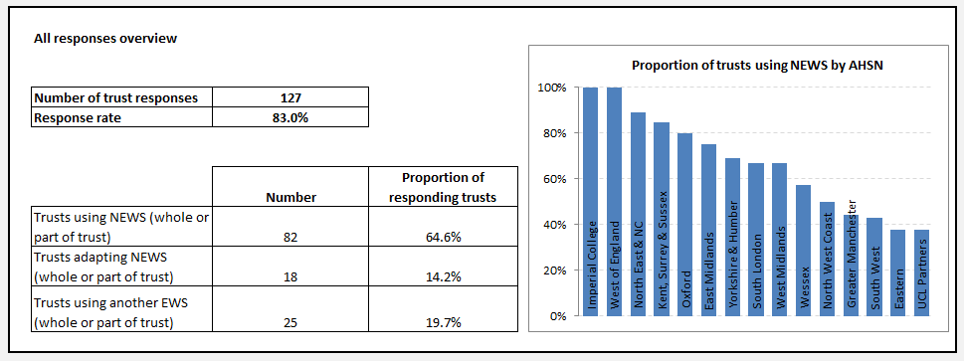

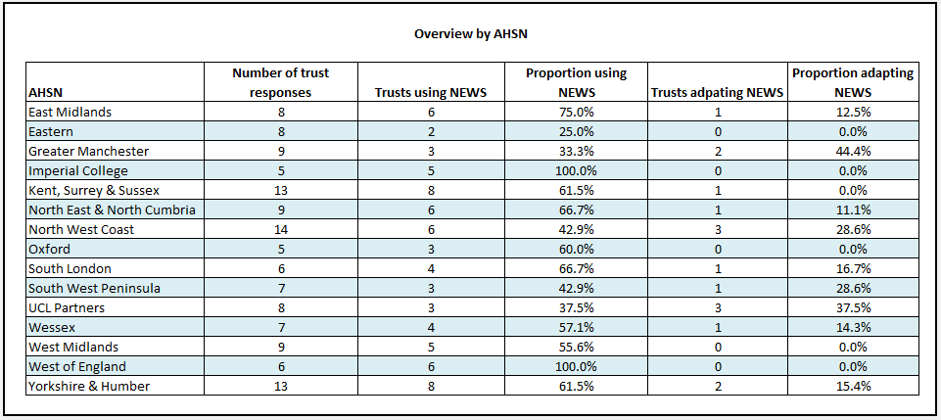

**NEWS 2 – key changes**

Since 2012 the NEWS has been widely adopted nationally across the NHS. NEWS has been shown to be good at discriminating risk of serious clinical deteriorating and acute mortality and therefore, NHS England and NHS Improvement have now approved and endorsed the NEWS across the health system to standardise the approach to detecting and grading illness severity in adult patients. Following the launch the Royal College of Physicians (RCP) encouraged user experience feedback to support improvement to NEWS processes. Like all quality improvement projects we expect this tool to continue to evolve. Two key concerns regarding the risk of over oxygenating hypercapnic respiratory patients and unreliability in spinal cord injuries have been addressed with the release of NEWS2. The West of England AHSN support the RCP recommendation to move to the updated NEWS2 model.

**The core principles of the NEWS, the scoring system and the thresholds and triggers remain unchanged however there are three key changes that should enhance the usability, safety and performance of the NEWS**

**Key changes The NEWS2 chart update**

1. Two scales now exist on the NEWS2 chart for scoring oxygen saturation. Scale 2 is designed to be used for patients with hypercapnic (often termed type 2) respiratory failure (usually due to COPD) who have clinically recommended oxygen saturation of 88–92%. This ensures the most appropriate application of supplemental oxygen, when required, for these patients.
2. recognition of the importance of new confusion (which includes disorientation, delirium or any new alteration to mentation) as a sign of potentially important clinical deterioration. This is reflected in the addition of ‘C’ to the Alert, Voice, Pain, Unresponsive (AVPU) score, which becomes ACVPU. The patient has new-onset confusion, disorientation and/or agitation, where previously their mental state was normal – this may be subtle. The patient may respond to questions coherently, but there is some confusion, disorientation and/or agitation. An acutely confused patient scores 3 for level of consciousness and in itself should prompt an urgent clinical review due to the NEWS single red score parameter trigger.
3. a strong emphasis on the potential use of the NEWS to identify serious sepsis in patients with

known or suspected infection, or at high risk of infection. NEW score of 5 or more is the key trigger threshold for urgent clinical review and action. Therefore clinicians should ‘think sepsis’ in all patients, with a NEWS of 5 or more with known or suspected infection, or those at risk of infection.

**Other changes to be aware of;**

1. the recording of physiological parameters has been reordered to align with the Resuscitation

Council (UK) ABCDE sequence the ranges for the boundaries of each parameter score are now shown on the chart. Note – the thresholds and escalation points have not changed but these changes support the recognition of subtle signs of deteriorating in track and trigger patients prior to a threshold being reached

1. the section of the chart for recording the rate of (L/min) and method/device for supplemental

oxygen delivery has been improved to clarify that any patient who is currently receiving supplemental oxygen (whether this is prescribed home O2 or applied by a clinician) should receive a weighted score of 2

1. the chart has a new colour scheme, reflecting the fact that the original red–amber–green colours were not ideal for staff with red/green colour blindness.

*Chart 1- The NEWS scoring system*

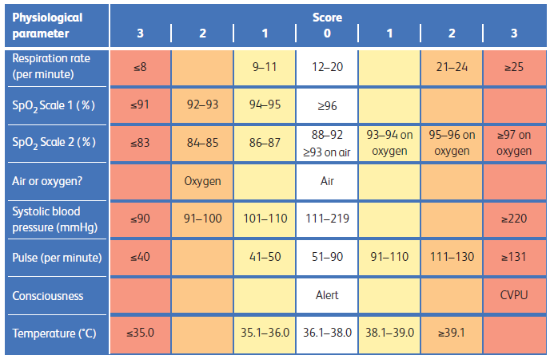

The West of England AHSN are in the process of updating our resources and website. Please note that this is not a full summary of NEWS 2 but a briefing paper to identify the key changes within NEWS2. Links to the executive summary, full report and monitoring chart can be found [here](https://www.rcplondon.ac.uk/projects/outputs/national-early-warning-score-news-2)

Appendix B of the full report contains a summary of frequently asked questions

Updated training documents and web based educational tools are available in a variety of formats with specific modules on the key clinical changes. Case studies are also linked to your specified clinical area for a bespoke learning experience and can be found [here](https://tfinews.ocbmedia.com/) .