**Q News – 23rd May**

**QI Training**

All Qs are invited to take part in the fantastic QI training at Gloucester QI Academy.

If you would like to learn the basics of QI methodology, the bronze course would be perfect for you.

For information please visit [www.gloshospitals.nhs.uk/academy](www.gloshospitals.nhs.uk/academy%20)

To book your space, please email: [gsqia@glos.nhs.uk](mailto:gsqia@glos.nhs.uk)

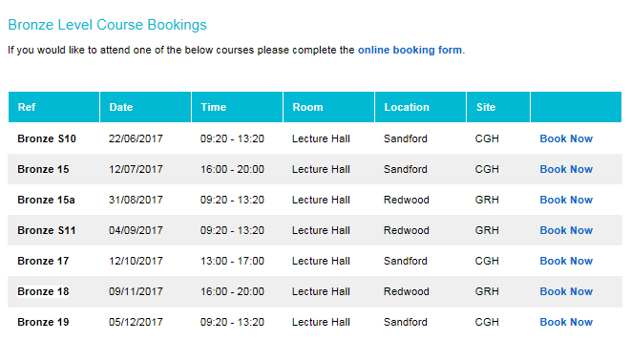

**Human Factors of Error Flyer**

Our fellow Q, Lynn at UHB Simulation Centre delivers this fantastic course in Patient Safety, human factors and investigation techniques.

**Q Interests** (with updates STP excel sheet)

Nicola Henderson

**Twitter Hour Banner**

**Q contacts booklet V04**

**QIQ&A**

**Election Paper 3**

**Atlas Case Studies**

[**Q – Get Involved**](https://q.health.org.uk/get-involved/)

**Videos**